Zabbix server 安装配置文档
环境准备
Zabbix Server需要运行在CentOS、RedHat Linux、Debain等Linux系统上，这里以CentOS6作为部署环境，Root用户安装必须的包，建议配置好yum，通过yum安装下列包，解决包的依赖关系。
1) LAMP(Linux + Apache + Mysql + PHP)环境
yum install mysql-server httpd php
- 安装依赖包
yum install mysql-devel net-snmp-devel OpenIPMI-devel openssl-devel fping-devel libcurl-devel perl-DBI php-gd php-mysql php-bcmath php-mbstring php-xml gcc
- 可以到官网下载最新安装包
http://jaist.dl.sourceforge.net/project/zabbix/ZABBIX%20Latest%20Stable/2.2.3/zabbix-2.2.3.tar.gz
或者采用yum安装
http://repo.zabbix.com/zabbix/2.2/rhel/6/x86_64/ 红帽yum源
安装步骤
- 创建zabbix用户和组
groupadd zabbix
useradd zabbix -g zabbix
- 创建数据库，添加授权账号
create database zabbix character set utf8;
grant all privileges on zabbix.* to zabbix@localhost identified by 'zabbix';
- 编译安装zabbix
tar xzf zabbix-2.2.3.tar.gz
cd zabbix-2.2.3
./configure --prefix=/usr/local/zabbix --enable-server --enable-agent \
--with-mysql --with-net-snmp --with-libcurl
make install
- 导入数据库
mysql -uzabbix -pzabbix -hlocalhost zabbix < database/mysql/schema.sql
mysql -uzabbix -pzabbix -hlocalhost zabbix < database/mysql/images.sql
mysql -uzabbix -pzabbix -hlocalhost zabbix < database/mysql/data.sql
- 修改配置文件
cp misc/init.d/fedora/core/zabbix_server /etc/init.d/
cp misc/init.d/fedora/core/zabbix_agentd /etc/init.d/
cp -R frontends/php /var/www/html/zabbix
sed -i 's/^DBUser=.*$/DBUser=zabbix/g' /usr/local/zabbix/etc/zabbix_server.conf
sed -i 's/^.*DBPassword=.*$/DBPassword=123456/g' /usr/local/zabbix/etc/zabbix_server.conf
sed -i 's/BASEDIR=\/usr\/local/BASEDIR=\/usr\/local\/zabbix/g' /etc/init.d/zabbix_server
sed -i 's/BASEDIR=\/usr\/local/BASEDIR=\/usr\/local\/zabbix/g' /etc/init.d/zabbix_agentd
- 添加服务端口
cat >>/etc/services <<EOF
zabbix-agent 10050/tcp Zabbix Agent
zabbix-agent 10050/udp Zabbix Agent
zabbix-trapper 10051/tcp Zabbix Trapper
zabbix-trapper 10051/udp Zabbix Trapper
EOF
- 启动服务并开机启动
/etc/init.d/zabbix_server start
/etc/init.d/zabbix_agentd start
echo "/etc/init.d/zabbix_server start" >> /etc/rc.local
echo "/etc/init.d/zabbix_agentd start" >> /etc/rc.local
8）修改php.ini
Vi /etc/php.ini
memory_limit = 256M
date.timezone = Asia/Shanghai
post_max_size = 32M
max_execution_time = 600
upload_max_filesize = 16M
max_input_time = 600
9）web页面安装配置，打开浏览器输入http://zabbix server ip地址/zabbix
确认每个Required都是ok的才会显示Next按钮，如果有Fail的需要完善系统要求
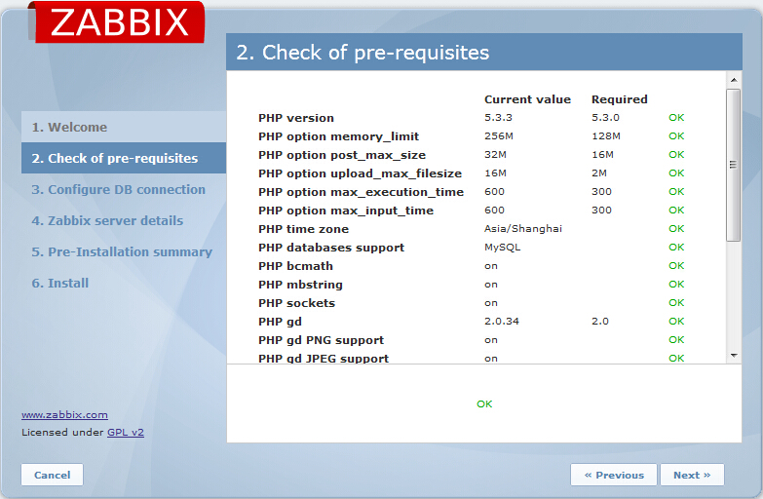
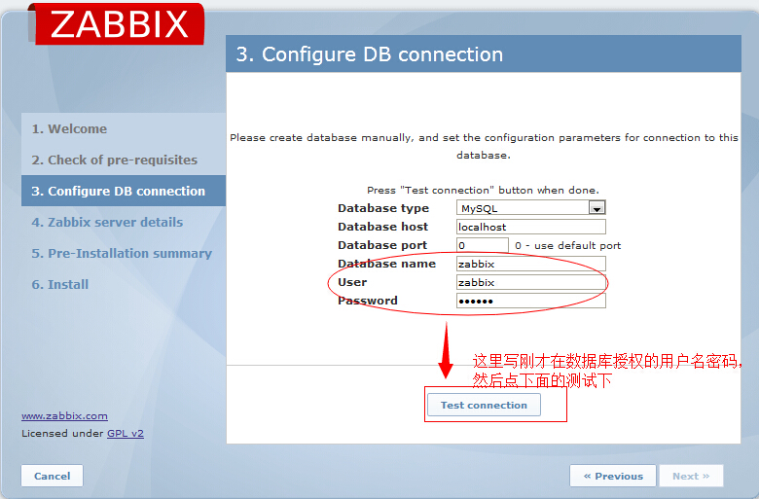
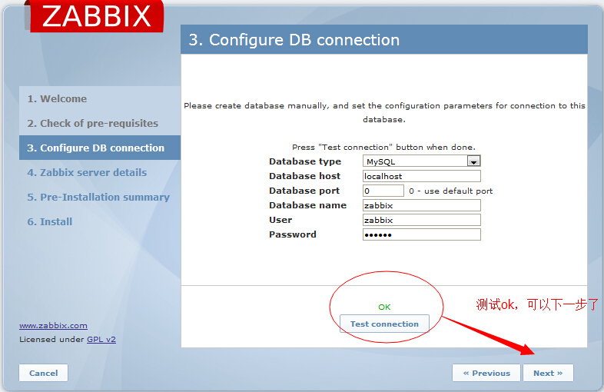
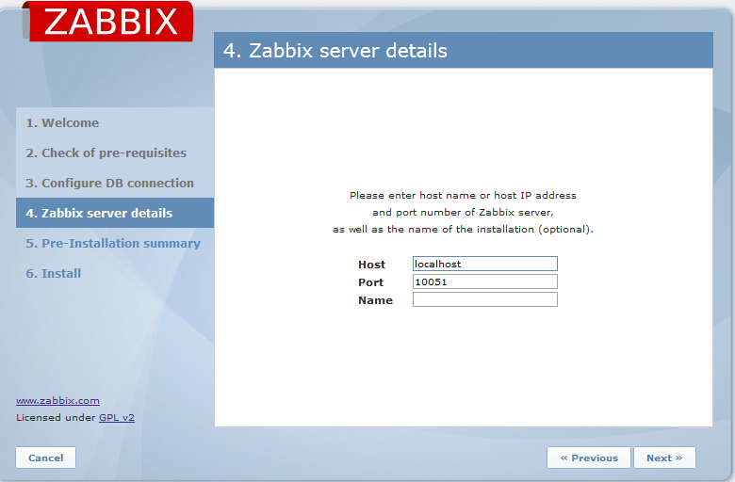
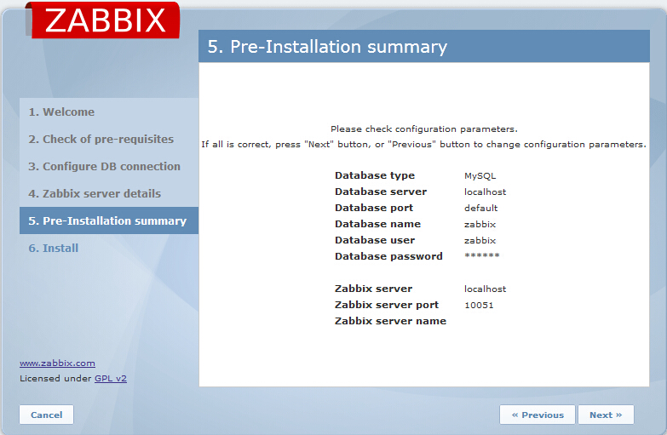
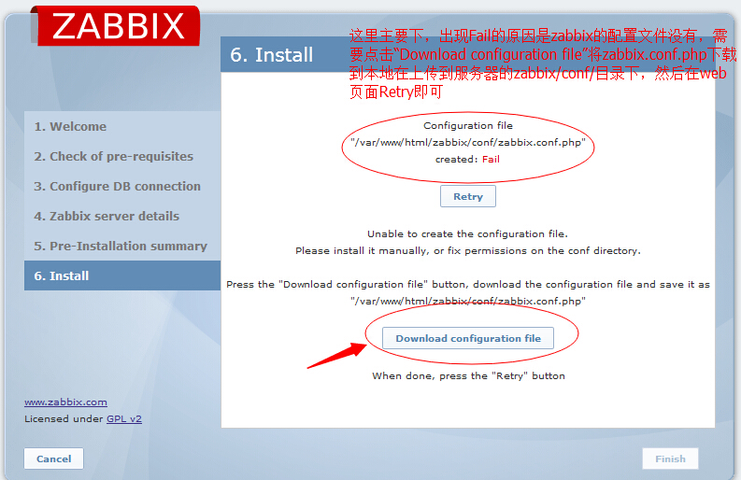
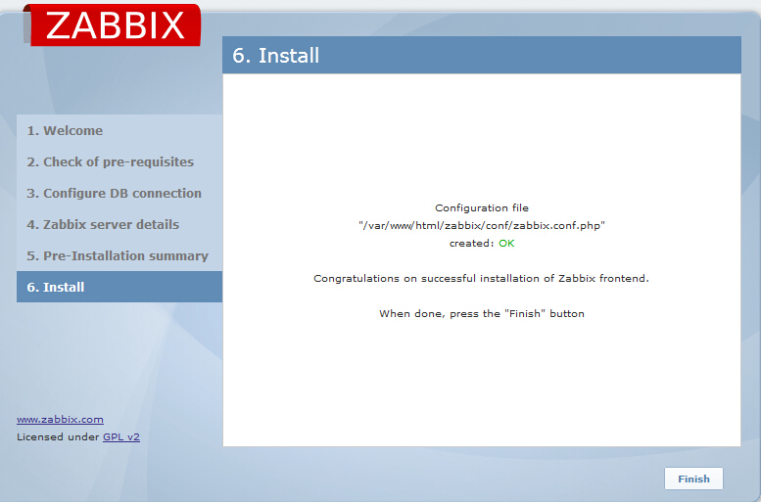
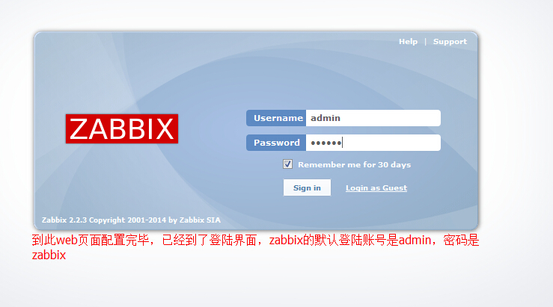
更换中文字体，登陆后在页面的右上边点击“Prefile”
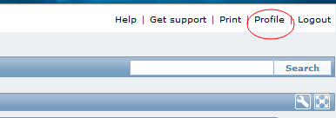
在Language选项中选择“Chinese（zh_CN）”，然后Save
